

**2025 NZGIC “WHOLE OF GOLF” CONFERENCE AND FINE TURF SEMINAR**

**ELLERSLIE EVENT CENTRE**

**AUCKLAND**

**AUGUST 17-19, 2025**

**DELEGATES REGISTRATION FORM**

**DELEGATE PARTNER**

**YOUR DETAILS**

Last Name

Title (Mr. / Mrs. / MS etc.) / First Name

Club

Position

Dietary / Special Requests

**NZGIC/GMANZ/PGA/NZGCSA** Member Yes

*The Privacy Act 1993 requires that before we can publish your name, address and any details in the list of delegates provided to sponsors, you must give your consent. Tick here if you* ***DO NOT*** *want your details to appear on a delegate list.*

**HOW DO WE CONTACT YOU: DELEGATE PARTNER______**

Club/Business Postal Address

Suburb, City & Postcode

Daytime & Mobile Number

Email Address

Add extra delegates names and email addresses here

1. First Name Last name Email address

2. First Name Last name Email address



**New Zealand Golf Industry Council PO Box 39 272, Howick, Auckland, 2145 T +64 21 392 007 E: admin@nzgic.co.nz**

**MY REGISTRATION CATEGORY**

**DELEGATE - MEMBER DELEGATE NON-MEMBER DELEGATE PARTNER**

**SPONSOR TRADE SHOW EXHIBITOR DINNER GUEST DAY GUEST**

**EARLY BIRD REGISTRATION FEES* DELEGATE PARTNER_______**

**NZGIC/CMA NZ/PGA/NZGCSA** Member *(and additional Club Delegates)* $600.00 + GST $600.00 + GST

**NZGIC/CMA NZ/PGA/NZGCSA** Member - *three delegate option* $1650.00 + GST

Non **NZGIC/CMA NZ/PGA/NZGCSA** Member *(and guests)* $650.00 + GST $650.00 + GST

*Early bird registration fees include the cost of the gala awards dinner. Early bird offers closes June 6, 2025

**REGISTRATION FEES* DELEGATE PARTNER_______**

**NZGIC/CMA NZ/PGA/NZGCSA** Member *(and additional Club Delegates)* $650.00 + GST $650.00 + GST

**NZGIC/CMA NZ/PGA/NZGCSA** Member - *three delegate option* $1800.00 + GST

Non **NZGIC/CMA NZ/PGA/NZGCSA** Member *(and guests)* $700.00 + GST $700.00 + GST

Day Session Guest – Tuesday or Wednesday (*circle selected day)* $250.00 + GST $250.00 + GST

Club Car Conference Gala Awards Dinner Guest as an extra person $200.00 + GST $200.00 + GST.

*Registration fees include the cost of the gala awards dinner.

**MIX AND MINGLE SUNDAY NIGHT DELEGATE PARTNER**

I / We will attend the Mix and Mingle Event **YES / NO** **YES / NO**

**REGISTRATION FEES**

Conference Early bird Registration Fee up to June 6, 2025, **$**

Conference Standard Registration Fee after June 6, 2025**, $**

Day Session Guest $250.00+ GST $

Conference Dinner Guest $200.00 + GST **$**

Subtotal (excluding GST) **$**

GST at 15% **$**

Total Cost Payable (including GST) **$**

**PAYMENT OPTIONS**

**On Invoice:** Please forward an invoice to facilitate payment.

**Direct Credit: Account Name**: New Zealand Golf Industry Council **Account No**: 12-3618-0029941-00

**Transaction Date: …………………………………………………Reference Used:……………………………………**

**Credit Card**: I authorise the organiser to debit $ from my credit card plus a 3% transaction fee.

**Card Number:**

**Card Type: ………………………………………………………….Expiry Date:…………………………………..**

**Name on Card …………………………………………………….. Signature: ……………………………………...**

**TERMS & CONDITIONS**

1. All prices are in New Zealand dollars and are exclusive of NZ GST which will be applied at 15%.
2. Payment by credit card incurs a 3% card fee.
3. Registration will be confirmed in writing, upon receipt of the total payment due.
4. Cancellation is required by written notice to the Organiser and will result in the following:
5. Prior to 6th June 2020, a full refund on the Registration Fee will be made less an administration fee of NZD $75.00 + GST
6. After 6th June 2020, no refund will be provided for any / all Registration Fees and Accommodation charges.
7. Accommodation is subject to availability.
8. The Host and Organiser reserve the right to alter the programme if required.

__________________________________________

**ACCOMMODATION – NOVOTEL ELLERSLIE AND IBIS ELLERSLIE**

Address: Novotel and IBIS Auckland Ellerslie,72-112 Greenlane East, Ellerslie

D. +64(0) 9 529 9090 - F. +64(0) 9 529 9092

[www.accor.com](http://www.accor.com/)

Accommodation is the responsibility of each delegate. As the preferred accommodation providers Novotel and Ibis Ellerslie are offering 15% off their unrestricted flexible rate of the day for both properties.

Delegates can go to the **Accor Hotels website** [www.accorhotels](http://www.accorhotels), **then go to Auckland Hotels/Novotel Ellerslie,** select the dates, request availability, add the group code under **“Codes and Options”** then update options.

|  |  |  |
| --- | --- | --- |
| **Room Type** | **Single Occupancy** | **Double Occupancy** |
| Standard King Single Room | 15% off rate applicable | N/A |
| Standard King Double Room | 15% off rate applicable | 15% off rate applicable |

Extra breakfast charge $32.00+GST

**Terms and Conditions:**

• Room rate is Room only, per room, per night and inclusive of GST.

• Rooms & Rates are subject to availability.

• All reservations must be guaranteed with a credit card valid at the date of the start of your stay, unless otherwise specified.

• No cancellation charge applies prior to 18:00 (local time), up to 7 days prior to arrival. Beyond that time, the first night will be charged.

• In the event of no-show, 1st night accommodation will be charged to the credit card used for guarantee, the remaining nights will be cancelled without charge.

**All prices are in New Zealand Dollars GST inclusive**

**NOVOTEL ELLERSLIE**

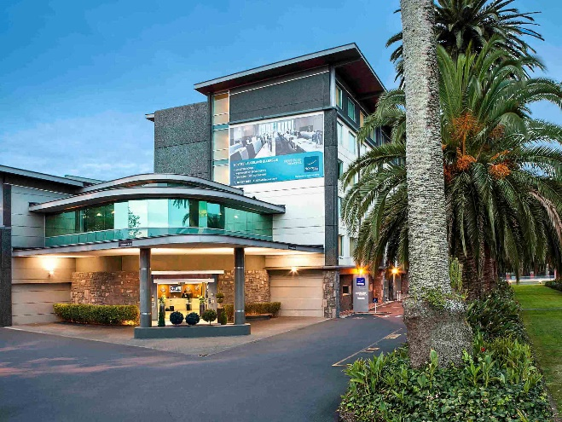

**IBIS ELLERSLIE**

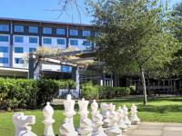

**The NOVOTEL ELLERSLIE HOTEL and IBIS HOTEL ELERSLIE**

provide the following facilities for your comfort:

Gym on level 1, open from 8am to 10pm

Laundry facilities on level 2, open from 8am to 10pm

24 hours reception and porter service

24 hours room service

Internet and Wi-Fi access (cost may apply)

Secured car park (fee apply)