**Principal Partner**

**Platinum and Naming Rights Partners**

**Platinum Partner**

**Gold partners**

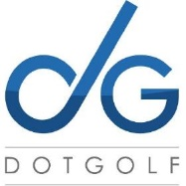

**Silver partners**

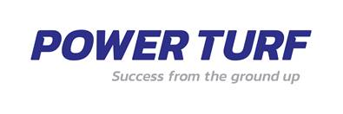

|  |  |
| --- | --- |
| Ezgo Logo   |  |
|  |  |
| signature_2315650196    Golf and Irrigation  NZSTI  A black background with grey letters  AI-generated content may be incorrect.  Auckland Council Logo Vector - 461311 |  | Point of Sale - SENPOS - Sharp Office    [A blue letter on a black background  AI-generated content may be incorrect.](https://myhr.works/)  Living Turf Established 2003 logo  Merigolf    A close up of a logo  AI-generated content may be incorrect.    A logo for a golf course  AI-generated content may be incorrect. |

**